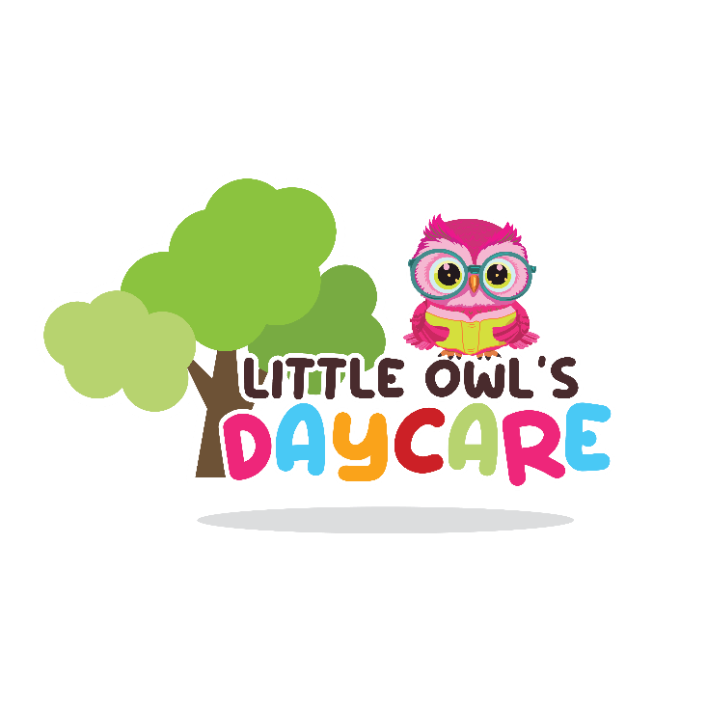

Our Purpose

Little Owl’s Daycare/Preschool believes that a high-quality program consists in having amazing teachers and staff that will enrich and engage with your child. Little owl’s welcomes all families from Yuma and its surroundings to a safe, love, fun, nurturing, early learning environment.

Director and Owner
Joan Guitron
Assistant Director
Marlene Osuna
Phone number:
(928) 256-3004
Email:
littleowlsdaycarecenter@gmail.com

Hours of Operation
Monday: 7:00 a.m. – 6:00 p.m.
Tuesday: 7:00 a.m. – 6:00 p.m.
Wednesday: 7:00 a.m. – 6:00 p.m.
Thursday: 7:00 a.m. – 6:00 p.m.
Friday: 7:00 a.m. – 6:00 p.m.

We closed during some holidays:
January 1st
Good Friday
Labor Day
Thanksgiving
Christmas
Any other day we will let parents know with time

Our Programs

Infants:
Birth – 12 months
Our infant class is designed for a safe, loved, and ready to explored classroom. A shoe free environment keeps their little hands and mouth safe from germs and dirt while they discover the world.
Whether you breastfeed or bottle-feed, we’ll keep your infant fed, happy, and healthy. Our center has policies to carefully label and separate breast milk and formula. You are always welcome to feed you baby!

Toddler 1 and 2:
Our toddler class is designed and organized for their age and stage of learning and development. As wondering means they’re learning and discovering new things every day. Our caring teachers set a daily schedule that includes group time, story time, outdoor play, meals and snacks, naps, and playtime because children learn by playing.

Preschool- 3, 4, 5:
Welcome to our preschool class were it’s all about expression Every day in our preschool class your child will explore science, create amazing art work, math, writing, pretend-play, and many other areas of learning that will help your child prepared them for kinder transition.
Full Time Tuition & Fees
Infants: $170.00
Toddlers: $170.00
Preschool: $170.00
Enrollment Fee: $70.00 is not refundable but will count for the tuition of the week for your child. This fee will be hold for 3 days if you failed to attend or call your registration agreement will cancel and the enrollment fee is not refundable.
Infants, Toddlers, Preschool: Tuition is paid a week in advance of $170.oo. If the center closes a day, you would not ask to pay for that day or if a holiday falls in that week. But if your child is absence, you are responsible to pay the flat tuition.
Part Time Tuition
Part time is a 4hr program, if less time is required you still be charge for part time of the 4hr of $130 per week.
Tuition Payment:
Payment is paid in front office by cash, card, and also you may make your payment by ProCare Solutions page.
Payments are paid full one week in advance every Thursday. No refunds if child is absence or if child was sent home due to contagious illness/infestation.
Late Fee:
A late fee will be charge of $10.00 per minute after your schedule time that was assign when register with director or assistant director. (We will only give 5min of tolerance) after this 5min your charge will start adding.

Enrollment:
Parents/care givers must fill require information and provide us with child’s immunizations to preside with enrollment. Please contact our office or in person for more information. (928) 256-3004
If no space is available for your child you are going to be ask if you want to be place on our waiting list. As soon we have a space available for your child you will be contact.

Termination:

- If child is absence for more than 3 days in a roll without any contact of parents or any other adult authorize to confirm the reason of absences.
- No payments have been done
- Parent’s/caregivers not being polite and verbal threats towards staff.
- Parent’s not willing to participate with program regarding child’s needs, behavior.

Abuse and Neglect:
Little Owl’s Daycare is required to report any neglect or abuse suspected to any child attending our center. Our staff will report to director and it will be documented on AZDHS FORM and reported immediately to child protective services agency.

Updating Information:
Please notify the office if any information changes regarding
Your child’s immunization, address, phone number, or any other important information the center is required to be inform.

Fieldtrips
Are not provided
Transportation
Not provided

Medication (RX)

Little Owl’s will provide medication ONLY! If contains;
- Physician Name and phone number
- Pharmacy information
- Parents must sign medication form before can administered medication.
- Full name of your child
- Instruction of how to administered medication
- Date of expiration
- Dooce & time of last doses.
- Everything must be written in English.
- Medication from Mexico is accepted but must follow same rules and written in English.

Sick Child Policy:

If your child presents any signs of sickness or any communicable disease such as; fever (100.1 degrees F or higher,) vomiting or diarrhea before coming to the center please keep them at home to prevent any from spreading to other children. If your child presents any symptoms while being here parents are going to be contacted to pick up your child as within 30 min of notice. Child may return back after a 24hr with no symptoms. We will require a doctor’s note confirming child is free from illness to transmit any virus or disease. If no note is presented child will not be accepted until you provide a note.

Nutrition Meals:

Little Owl’s provide healthy meals for your child.
Our meals are delivered during the day for our little ones to enjoy.
Every month we will send home our menu for parents. Our teacher’s and staff will model healthy nutrition habits. During our meals we practices family style routines. (Please let us know if your child has any allergies, we should be aware of).

Breakfast -- 8:00 a.m.
A.M. Snack: -- 10:00 a.m.
Lunch -- 12:00 p.m.
P.M snack -- 3:00 p.m.

If your child has any allergies, please let our front office know or your child teacher.

Accident/Incident Procedure:
If an accident/incident would off to occur during outdoor play, indoor activities the following procedures will be followed to document the accident/incident and to informed parents.
- Teacher/staff that was supervising child will check with child and see what was the reason of the accident/incident.
- If necessary, teacher staff will check if child needs any help.
- Teacher/staff will notify director of what happen
- If emergency would off happen parent will be notified as soon as possible.
- Documentation will be filled.
- Little Owl’s takes very seriously the subject of confidentiality

Drop off and Pick up Procedures:

Parents must always sign in and out when arriving and departure of the center. Child must arrive and depart at the time schedule with the director at the time of enrollment. If not, an extra feed will be charge. If child is missing any immunizations child is not going to be accepted until missing immunizations are up to date. For safety of your child an ID is going to be ask to any person picking your child from the emergency card. No exceptions

Being Absence:
If your child is going to be absence for the day or for a long period of time please call and let us know. Tree or more absences in a row could lead to a disenrollment. If child is absence, you are still responsible to pay your tuition for those days as you sign for the flat rate tuition for the week.

Daily Schedule:

Each of our classroom have a daily schedule and routines to fallow as the day precedes. It’s arranged for each classroom base on children age and stage. our routines are design for the children to learn development skills. Our daily schedule consists on morning welcome, breakfast, snacks, lunch, writing, math, outdoor play, science, reading, manipulatives, art, etc. For further questions please feel free to ask teachers or any of our staff.
Discipline:
Little Owl’s Daycare teachers and staff are not allowed to discipline any child by cruel punishment, negative remarks, use harsh, or unusual punishment, or verbal abuse towards any child. If you see or suspect of any situation, please let our center director immediately. Little owl’s Daycare practice a good discipline by teaching children that we have rules and we need to follow them for a good reason. Our teachers and staff help them understand this rule by practicing them every they in the classroom, and outdoor. If necessary, we do give time out only to children age 3 and up and teacher will talk to them in a way they understand why they are having time out. Teachers will let parent know about the time out, if necessary, a meeting will be arranged with parents, teacher and director.

Clothing:
Infants: Parents are responsible to provide dippers, wipes, 4 changes of clothing, feeding bottles, pacifier, if necessary, milk formula.
Toddlers: Parents are responsible to provide dippers, wipes, 3 changes of clothing.
Preschool: Parents, please provide 2 changes of clothing for any accidents that you child may have during any activity or bathroom accidents.
All dirty clothing will be sent home at the end of the day with your child.
Shoes: Please send your child with comfortable shoes, close shoes to prevent any accidents, and no high hills shoes for girls. If possible, no shoes with laces.

Uniform Policy:
Little Owl’s Daycare follows a uniform policy
For our toddlers and preschool age children.
Red polo shirt and navy-blue pants, shorts, skirts, or dress for girls.

Little Owl’s Daycare facility is regulated by Arizona Department of Health Services 400 W. Congress Ste. 100
Tucson, AZ 853701-1352
(520) 628-6540

All inspections and reports are available to parents. You are welcome to see at any time.

.

.

